Q1.Make a class named Fruit with a data member to calculate the number of fruits
in a basket. Create two other class named Apples and Mangoes to calculate
the number of apples and mangoes in the basket. Print the number of fruits of
each type and the total number of fruits in the basket.
SOLUTION:-

Program:-

#include<bits/stdc++.h>
using namespace std ;
int c=0;
class fruit
{
public:
void adder()
{
c++;
}
int getter()
{
return c;
}
};
class apple: public fruit
{
public:
int a=0;
void adder(){
a++;
fruit::adder();
}
int getter(){
return a;
}
};
class mango: public fruit
{
public :
int m=0;
void adder()
{
m++;
fruit::adder();
}
int getter()
{
return m;
}
};

int main()
{
int NumOfFruit;
cin>>NumOfFruit;
mango m1;
apple a1;
fruit f1;
string fName;
for(int i=0;i<NumOfFruit;i++)
{
cout<<"Enter Fruit Name:";
cin>>fName;
if (fName=="Mango"||fName=="mango")
{
m1.adder();
}
else if(fName=="Apple"||fName=="apple")
{
a1.adder();
}
else
{
f1.adder();
}
}
cout<<"Number of fruits:"<<f1.getter()<<endl;
cout<<"Number of mangoes:"<<m1.getter()<<endl;
cout<<"Number of apples:"<<a1.getter()<<endl;
return 0;
}

Output:-

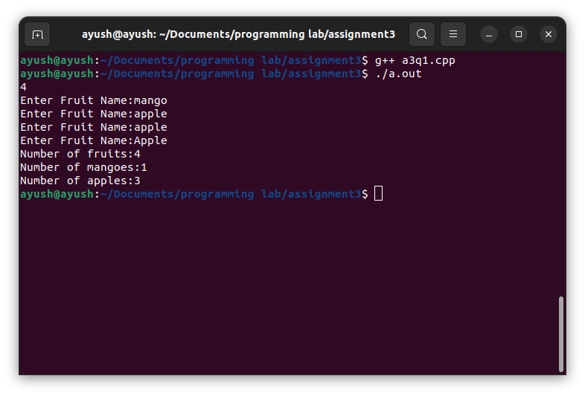

Q2.Create a class named Shape with a function that prints "This is a shape".
Create another class named Polygon inheriting the Shape class with the same
function that prints "Polygon is a shape". Create two other classes named
Rectangle and Triangle having the same function which prints "Rectangle is
a polygon" and "Triangle is a polygon" respectively. Again, make another
class named Square having the same function which prints "Square is a
rectangle".
Now, try calling the function by the object of each of these classes.
SOLUTION:-
Program:-
#include<bits/stdc++.h>
using namespace std;
class shape
{
public:
void display()
{
cout<<"This is a Shape"<<endl;
}
};
class polygon:public shape
{
public:
void display()
{
cout<<"polygon is shape"<<endl;
shape::display();
}
};
class rectangle:public polygon
{
public:
void display()
{
cout<<"rectangle is polygon"<<endl;
polygon::display();
}
};
class triangle:public polygon
{
public:
void display(){
cout<<"triangle is polygon"<<endl;
polygon::display();
}
};
class square:public rectangle
{
public:
void display(){
cout<<"square is rectangle"<<endl;
rectangle::display();
}
};
int main()
{
string shape_name;
cin>>shape_name;
if (shape_name=="square")
{
square sq;
sq.display();
}
else if(shape_name=="rectangle")
{
rectangle re;
re.display();
}
else if(shape_name=="triangle")
{
triangle tr;
tr.display();
}
return 0;
}
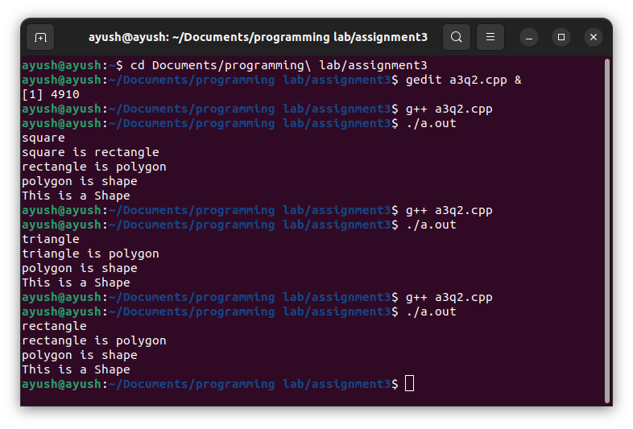
Output:-

Q3.An educational institution wishes to maintain a database of its employees. The
database is divided into a number of classes whose hierarchical relationships
are shown in below Fig. The figure also shows the minimum information
required for each class. Specify all the classes and define functions to create
the database and retrieve individual information as and when required.
SOLUTION:-
Program:-
#include<bits/stdc++.h>
using namespace std;
class staff
{
public:
int code;
string name;
staff()
{}
staff(int cod,string nam)
{
code=cod;
name=nam;
}
};
class teacher:public staff
{
public:
string subject,publication;
teacher(int cod,string nam,string subjec,string publicatio)
:staff(cod,nam)
{
subject=subjec;
publication =publicatio;
}
void display()
{
cout<<"\n\nEmployee code:-"<<code<<endl;
cout<<"Employee name:-"<<name<<endl;
cout<<"Employee's job:-Teacher"<<endl;
cout<<"Employee's subject:-"<<subject<<endl;
cout<<"Publication:-"<<publication<<endl;
}
};
class officer:public staff
{
public:
string grade;
officer(int cod,string nam,string grad)
:staff(cod,nam)
{
grade=grad;
}
void display()
{
cout<<"\n\nEmployee code:-"<<code<<endl;
cout<<"Employee name:-"<<name<<endl;
cout<<"Employee's job:-Officer"<<endl;
cout<<"Grade:-"<<grade<<endl;
}
};
class typist:public staff
{
public:
int speed;
typist(int cod,string nam,int spee):staff(cod,nam)
{
speed=spee;
}
};
class regular:public typist
{
public:
regular(int cod,string nam,int spee):typist(cod,nam,spee)
{}
void display()
{
cout<<"\n\nEmployee code:-"<<code<<endl;
cout<<"Employee name:-"<<name<<endl;
cout<<"Employee's job:-Typist"<<endl;
cout<<"Typist's type:-Regular"<<endl;
cout<<"Speed:-"<<speed<<" words/minute"<<endl;
}
};
class casual:public typist
{
public:
int dailywages;
casual(int cod,string nam,int spee,int dailywage):typist(cod,nam,spee)
{
dailywages=dailywage;
}
void display()
{
cout<<"\n\nEmployee code:-"<<code<<endl;
cout<<"Employee name:-"<<name<<endl;
cout<<"Employee's job:-Typist"<<endl;
cout<<"Typist's type:-Casual"<<endl;
cout<<"Employee's Dailywages:-"<<dailywages<<endl;
cout<<"Speed:-"<<speed<<" words/minute"<<endl;
}
};
int main()
{
int noOfEmp,code;
string name;
cout<<"Enter number of Employees:";
cin>>noOfEmp;
for (int i = 0; i < noOfEmp; i += 1)
{
cout<<"Enter name:";
cin>>name;
cout<<"Enter code:";
cin>>code;
cout<<"Enter job name:"<<endl;
string job;
cin>>job;
if (job=="teacher")
{
string subject,publication;
cout<<"Enter subject name:";
cin>>subject;
cout<<"Enter publication:";
cin>>publication;
teacher t(code,name,subject,publication);
t.display();
}
else if(job=="officer")
{
string grade;
cout<<"Enter Grade:";
cin>>grade;
officer o(code,name,grade);
o.display();
}

else if(job=="typist")
{
string type;
cout<<"Enter type of Typist:";
cin>>type;
int speed;
cout<<"Enter speed:";
cin>>speed;
if (type=="regular")
{
regular r(code,name,speed);
r.display();
}
else if(type=="casual")
{
int dailywages;
cout<<"Enter Dailywages:";
cin>>dailywages;
casual c(code,name,speed,dailywages);
c.display();
}
}
}
return 0;
}

Output:-

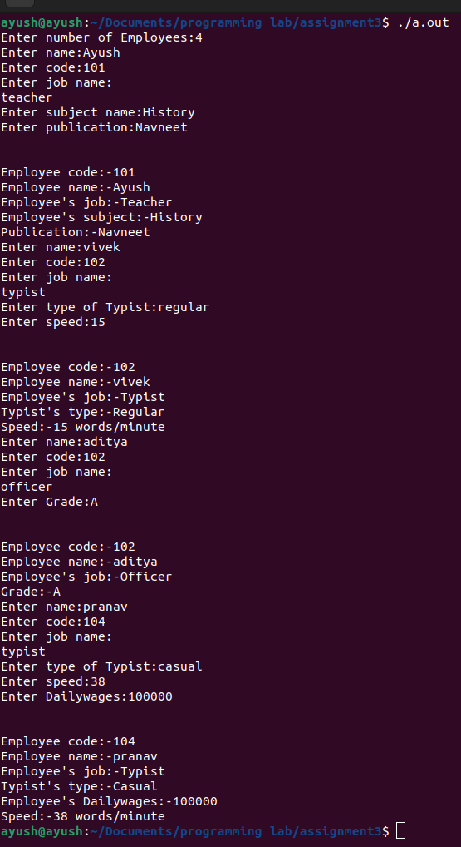
Q4.The database created in above example does not include educational
information of the staff. It has been decided to add this information to teachers
and officers (and not for typists) which will help the management in decision
making with regard to training, promotion, etc. Add another data class called
education that holds two pieces of educational information, namely, highest
qualification in general education and highest professional qualification. This
class should be inherited by the classes teacher and officer. Modify the above
program to incorporate these additions.
SOLUTION:-
Program:-
#include<bits/stdc++.h>
using namespace std;
class staff
{
public:
int code;
string name;
staff()
{}
staff(int cod,string nam)
{
code=cod;
name=nam;
}
};
class education
{
public:
string q_g_e,h_p_q;
education(string a,string b)
{
q_g_e=a;
h_p_q=b;
}
void display()
{
cout<<"Highest Qualification in General Education:"<<q_g_e<<endl;
cout<<"Highest Professional Qualification:"<<h_p_q<<endl;
}
};
class teacher:public staff,public education
{
public:
string subject,publication;
teacher(int cod,string nam,string subjec,string publicatio,string a,string b)
:staff(cod,nam),education(a,b)
{
subject=subjec;
publication =publicatio;
}
void display()
{
cout<<"\n\nEmployee code:-"<<code<<endl;
cout<<"Employee name:-"<<name<<endl;
cout<<"Employee's job:-Teacher"<<endl;
cout<<"Employee's subject:-"<<subject<<endl;
cout<<"Publication:-"<<publication<<endl;
education::display();
}
};
class officer:public staff,public education
{
public:
string grade;
officer(int cod,string nam,string grad,string a,string b)
:staff(cod,nam),education(a,b)
{
grade=grad;
}
void display()
{
cout<<"\n\nEmployee code:-"<<code<<endl;
cout<<"Employee name:-"<<name<<endl;
cout<<"Employee's job:-Officer"<<endl;
cout<<"Grade:-"<<grade<<endl;
education::display();
}
};
class typist:public staff
{
public:
int speed;
typist(int cod,string nam,int spee):staff(cod,nam)
{
speed=spee;
}
};
class regular:public typist
{
public:
regular(int cod,string nam,int spee):typist(cod,nam,spee)
{}
void display()
{
cout<<"\n\nEmployee code:-"<<code<<endl;
cout<<"Employee name:-"<<name<<endl;
cout<<"Employee's job:-Typist"<<endl;
cout<<"Typist's type:-Regular"<<endl;
cout<<"Speed:-"<<speed<<" words/minute"<<endl;
}
};
class casual:public typist
{
public:
int dailywages;
casual(int cod,string nam,int spee,int dailywage):typist(cod,nam,spee)
{
dailywages=dailywage;
}
void display()
{
cout<<"\n\nEmployee code:-"<<code<<endl;
cout<<"Employee name:-"<<name<<endl;
cout<<"Employee's job:-Typist"<<endl;
cout<<"Typist's type:-Casual"<<endl;
cout<<"Employee's Dailywages:-"<<dailywages<<endl;
cout<<"Speed:-"<<speed<<" words/minute"<<endl;
}
};
int main()
{
int noOfEmp,code;
string name;
cout<<"Enter number of Employees:";
cin>>noOfEmp;
for (int i = 0; i < noOfEmp; i += 1)
{
cout<<"Enter name:";
cin>>name;
cout<<"Enter code:";
cin>>code;
cout<<"Enter job name:"<<endl;
string job;
cin>>job;
if (job=="teacher")
{
string subject,publication,a,b;
cout<<"Enter subject name:";
cin>>subject;
cout<<"Enter publication:";
cin>>publication;
cout<<"Enter Highest Qualification in General Education:";
cin>>a;
cout<<"Enter Highest Professional Qualification:";
cin>>b;
teacher t(code,name,subject,publication,a,b);
t.display();
}
else if(job=="officer")
{
string grade,a,b;
cout<<"Enter Grade:";
cin>>grade;
cout<<"Enter Highest Qualification in General Education:";
cin>>a;
cout<<"Enter Highest Professional Qualification:";
cin>>b;
officer o(code,name,grade,a,b);
o.display();
}
else if(job=="typist")
{
string type;
cout<<"Enter type of Typist:";
cin>>type;
int speed;
cout<<"Enter speed:";
cin>>speed;
if (type=="regular")
{
regular r(code,name,speed);
r.display();
}
else if(type=="casual")
{
int dailywages;
cout<<"Enter Dailywages:";
cin>>dailywages;
casual c(code,name,speed,dailywages);
c.display();
}
}
}
return 0;
}
Output:-
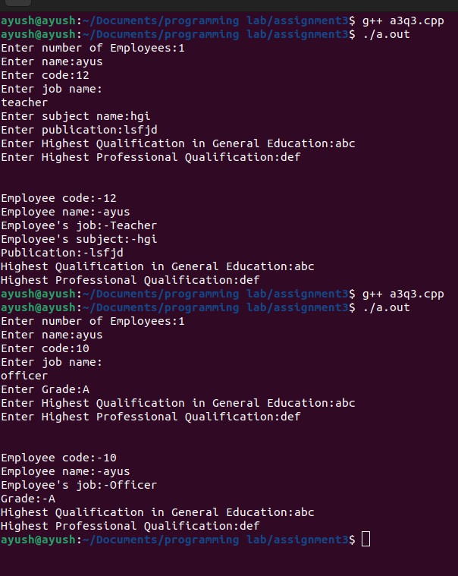

Q5.Using Hybrid inheritance, design a program which will solve real life
problem.
SOLUTION:-
Program:-
#include <iostream>
using namespace std;
class Plants
{
public:
Plants(){
cout<< "This is a producer\n";
}
};
class Herbivores: public Plants
{
public:
Herbivores() {
cout<< "This is a primary consumer\n";
}
};
class Carnivore: public Herbivores
{
public:
Carnivore()
{
cout<< "This is a secondary consumer\n";
}
};
class Secondary_Carnivore: public Carnivore
{
public:
Secondary_Carnivore()
{
cout<< "This is a tertiary consumer\n";
}
};
int main() {
Secondary_Carnivore s;
return 0;
}

Output:-
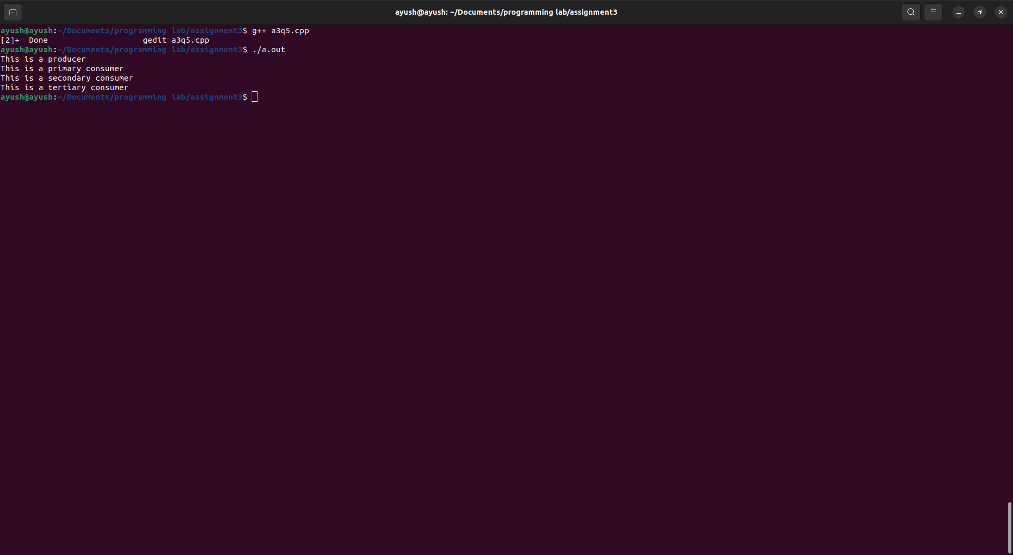
Q6.Design a class Polar which describes a point in the plane using polar
coordinates radius and angle. A point in polar coordinates is shown in below
Fig. Use the overloaded + operator to add two objects of Polar. Note that we
cannot add polar values of two points directly. This requires first the
conversion of points into rectangular co-ordinates, then adding the
corresponding rectangular co-ordinates and finally convening the result back
into polar co-ordinates.
You need to use the following trigonometric formulae:
x = r * cos(a);
y = r * sin(a);
a =a tan(y/x); // arc tangent
r =sqrt(x*x + y*y);
SOLUTION:-
Program:-
#include<iostream>
#include<cmath>
using namespace std;

class Polar
{
public:
float r;
float a;
Polar(float a=0,float r=0)
{
this->a=a;
this->r=r;
}
Polar operator + (Polar const &obj) {
Polar res;
float x1=r*cos(a),y1=r*sin(a),x2=obj.r*cos(a),y2=obj.r*sin(a);
x1+=x2;
y1+=y2;

if(x1==0)
a=90.00;

else
a=atan(float(y1/x1));
r=sqrt(((x1*x1)+(y1*y1)));
res.a=a;
res.r=r;
return res;
}

void display()
{
cout<<"The radius is :"<<this->r<<endl;
cout<<"The angle is :"<<this->a<<endl;
}
};
int main()
{
Polar p1(90.00,10),p2(0.00,20);
Polar p3=p1+p2;
p3.display();
return 0;
}
Output:-
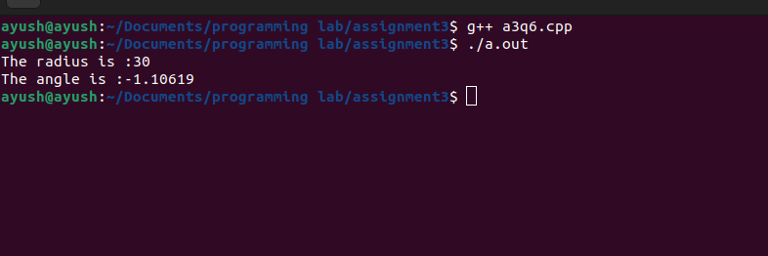
Q7. Create a class INTEGER that contains one float data member. Overload all
the four arithmetic operators so that they operate on the objects of INTEGER.
SOLUTION:-
Program:-
#include <bits/stdc++.h>
using namespace std;
class INTEGER
{
float a;
public:
INTEGER(float a)
{
this->a=a;
}

float operator+(INTEGER I)
{
return(a+I.a);
}

float operator-(INTEGER I)
{
return(a-I.a);
}

float operator*(INTEGER I)
{
return(a*I.a);
}

float operator/(INTEGER I)
{
return(a/I.a);
}
};

int main()
{
INTEGER I1(10.10),I2(20.50);

cout<<"\nOperator + : \n"<<I1+I2;
cout<<"\nOperator + : \n"<<I1-I2;
cout<<"\nOperator + : \n"<<I1*I2;
cout<<"\nOperator + : \n"<<I1/I2;
return 0;

}

Output:-
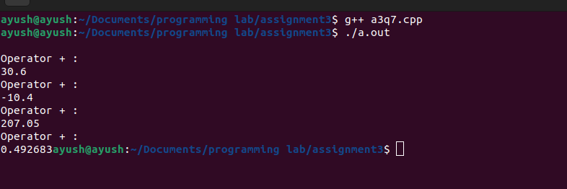
Q8.Create a class MAT of type m*n. Define all possible matrix operations for
MAT type objects.
SOLUTION:-
Program:-
#include <bits/stdc++.h>
using namespace std;

class MAT
{
int a[2][2];

public:
void accept()
{
cout << "Enter the 4 elements" ;
for (int i = 0; i < 2; i++) {
for (int j = 0; j < 2; j++) {
cin>>a[i][j];
}
}
}

void display()
{
for (int i = 0; i < 2; i++)
{ cout<<endl;
for (int j = 0; j < 2; j++)
{
cout<<" "<<a[i][j];
}
}
}

MAT operator+(MAT M2)
{
MAT M3;
for (int i = 0; i < 2; i++)
{ cout<<endl;
for (int j = 0; j < 2; j++)
{
M3.a[i][j]=a[i][j]+M2.a[i][j];
}
}
return M3;
}
MAT operator*(MAT M2)
{
MAT M3;
for (int i = 0; i < 2; i++)
{
for (int j = 0; j < 2; j++)
{
M3.a[i][j]=0;
for (int k = 0; k <2; k++)
{
M3.a[i][j]=(a[i][k]*M2.a[k][j]+M3.a[i][j]);
}
}
}
return M3;
}

};
int main()
{
MAT M1,M2,M3;
cout<<"\n\n enter the first matrix";
M1.accept();
cout<<"\n\n enter the second matrix";
M2.accept();
M3=M2+M1;
cout<<"\n\n addition is :";
M3.display();
M3=M2*M1;
cout<<"\n\n multiplication is :";
M3.display();
return 0;
}

Output:-
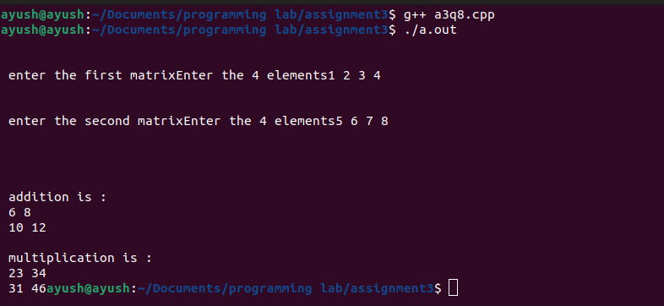
Q9. Define a class String. Use overloaded = = operator to compare two strings.
SOLUTION:-
Program:-
#include<iostream>
#include<stdio.h>
#include<string.h>
using namespace std;

class String
{
string str;
public:

void getdata(string a)
{
str=a;
}

int operator ==(String s)
{
if(str==s.str)
return 1;

return 0;
}
};

int main()
{
String s1,s2;
string a,b;
cout<<"Enter first string :: ";
cin>>a;
s1.getdata(a);
cout<<"\nEnter second string :: ";
cin>>b;
s2.getdata(b);
if(s1==s2)
{
cout<<"\nStrings are Equal\n";
}
else
{
cout<<"\nStrings are Not Equal\n";
}

return 0;
}
Output:-
